Arw ‘s Heels on the ground newsletter
Executive Committee:(Left to right:) Connie Boyer, Treasurer, Peggy Buckels, Recording Secretary, Iris Milligan, Parliamentarian, & Marian Laughlin, President,
1st VP Program ,Dawn LaViolette, 2nd VP Marsha Vining email: arw2022@gmail.com

PRESIDENT Marian Laughlin’s AUGUST 2023 MESSSAGE TO MEMBERSHIP: WELCOME MEMBERS AND ASSOCIATES TO THE ACADIANA REPUBLICAN WOMEN CLUB. I HOPE THAT YOU WILL JOIN US IN OUR Community work.
as well as our political endeavors as we work towards the 2024 Election. PHOTO:
Left to right President Marian Laughlin, Treasurer Connie Boyer, Principal Carlie Rozell, Elizabeth Landry, Counselor 3-4 grade, Parl. Iris Milligan, Awards Helen Granger, and Newsletter Carita Wilson DELIVERY OF SCHOOL SUPPLIES FROM ARW. 8-1-23
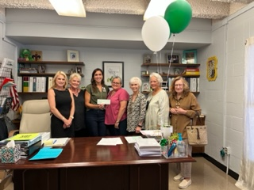I want to thank our members, associates, and guests who gave so generously for our school Supply drive at the July meeting. The staff at Katherine Drexel elementary school were very appreciative!

Our Speakers for the August 15th Meeting are: Rep. Blake Miguez candidate for State Senate District 22 and Brandon Trosclair candidate for Secretary of State.

Venmo pay is now available: ARW CLUb @ ARW-CLUB But please remember to RSVP by Noon on the 13th!

Sincerely, Marian Laughlin, ARW President

Sincerely, Marian Laughlin, ARW President

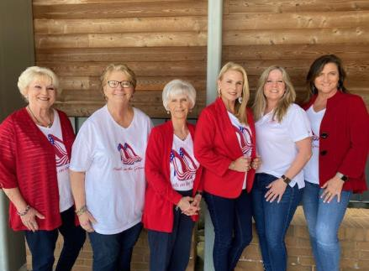
.

ARW EXECUTIVE COMMITTEE
PRESIDENT
Marian Laughlin arw2022@gmail.com
IMMEDIATE PAST PRESIDENT
Patricia Soulier patricia.soulier @hotmail.com
FIRST VICE PRESIDENT
Program Chairman Dawn LaViolette dawnlav4@gmail.com
SECOND VICE PRESIDENT
Marsha Vining mvining1969@gmail.com RECORDINGSECRETARY Peggy
Buckels,peggyjb@lusfiber.net
CORRESPONDING SEC Joyce
Linde,joyce.linde@lusfiber.n et
TREASURER
Connie Boyer Conray2@cox.net.
Parliamentarian Iris Milligan
raa4847@att.net
NEWLETTER EDITOR CARITA WILSON
Wcarita943@gmail.com
Chaplin Anita Johnson
Email for LFRW:
Web site: LFRW.org
Use your email address & password issued to you by LFRW Webmaster.
Facebook: LFRW/Facebook
NFRW
Web site: www.nfrw.org Member Web site:ARW
Members use this email for ARW:
arw2022@gmail.com

Facebook:ARW PAGE , TWITTER is now called X , TRUTH SOCIAL.

Disclaimer: campaign information in this newsletter is provided as a courtesy to the candidate and should not be considered an endorsement by LFRW/A RW

Page 2
MEETINGS for Organizations
AUGUST 15TH, 2023 ARW TUESDAY MEETING

Please remember to make your reservation: RSVP contact: Connie Boyer: Conray2@cox.net (or) Text337-2880568 -Meetings are from 5:30PM {Doors open) starts @ 6:00 PM at River Oaks Catering Center and Dinner is $25.00( extra
$5.00 if you did not RSVP) Tell Connie when you RSVP if you need a Ride to Night Meeting (1 week before Meeting)
Please come and welcome Our Speakers: Early Voting is October 14, 2023
CALENDAR EVENTS: A 2023 1.) City

Council meetings 1st, & 3rdTuesday of each month at 5:30 PM @ City Hall.
- Lafayette Parish Executive Committee (PEC) 2nd Monday of month /NOON @ Pizza Village on Kaliste Saloom.

- Republican State Central Committee (RSCC) is 10:00 Am Saturday July 22nd in Baton Rouge.
Many hospitality’s Suites on Friday July 21st before Meeting.
.
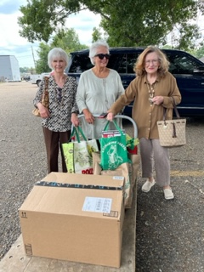
Iris, Helen, Carita July 2023
Katherine Drexel Elementary
- Mayor/President Josh Guillory Meeting: 3RD Thursday of the Month @ 2:00PM, City Hall.

5.) ARW Monthly Executive Committee 2nd Wednesday /month 9:30am/12pm: Board Meeting Last Wednesday of the Month.
6.) ARW monthly Dinner meetings on the 3rd Tuesday of each month - Meetings 5:30PM (Doors open) 6:00 PM Starts @ River Oaks Catering Center, Cost: $25.00 Buffet Dinner (with RSVP) if not $30.00 Reservations are required. RSVP:
Connie Boyer, conray2cox.net, Text 337-288- 0568.
If you need a driver/ride for night meetings tell Connie when you RSVP 1 week before Meeting.

Red Shoe Book Club Carita Wilson, Chairman: 76theresa@gmail.com Book Club for July was Friday28th.BookClub met at Rachel’s, Cafe@ 11:30 Discussion of books lasted until
1: 00PM,. Helen’s Book, Covenant of Water by Abraham Verghese. Bernie’s book was by Janice Dean(Fox TV Weather girl) Make your Own Sunshine, Sandra read Confederacy of Dunces, Gail read The Puppeteers (The People who Control the People Who Control America) By Jason Chaffetz and Carita read Stephen King the Book Under the Dome and she and her husband watched the Under the Dome TV series on a weekend! Spooky but fun. Good Discussion by all. Food was yummy. We enjoyed having Connie Boyer as our guest this month.
ARW DONATED $800.00 TOTAL IN MOMEY AND DONATED SCHOOL SUPPLIES FROM MEMBERS, ASSOCIATES & GUESTS! TO Katherine Drexel Elementary School
Carita’s 1 year old grandson reading his dinner menu.
I would like the members to submit a photo of their child, grandchild, niece, or nephew reading; as School starts this month and I will include all photos in September newsletter! Only if you want to. TKS
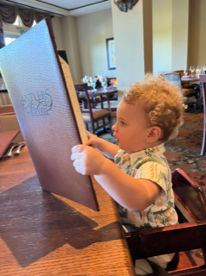

,

Disclaimer: campaign information in this newsletter is provided as a courtesy to the candidate not an endorsement by ARW

Page 3
Read the Legislative News by Susie Labry lasunshinebr@yahoo.com sent to you by ARW President Marian Laughlin
This update will give you all the happenings in Baton Rouge on Life, Guns, Health Freedom, Election Integrity, Carbon Capture and more. See all the House Bills and the Votes and activities surrounding “How you can help pass a vote or defeat a vote.” You the Voter can be involved now before an election.
DID YOU KNOW? TWITTER IS NOW KNOWN AS X ARW HAS AN ACCOUNT, CHECK IT OUT!
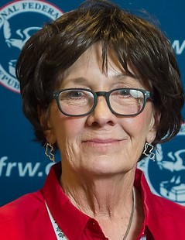Pat Soulier, Past President of ARW, husband’s funeral was on August 1, 2023 at Martin & Castille’s Funeral home and ARW Board, and Members attended the Funeral to support Pat and their son, Matt and his family at this difficult time. Randy died July 23, 2023.
PLEASE SAY A PRAYER FOR THE SOULIER FAMILY.
:

YOUR AD ?
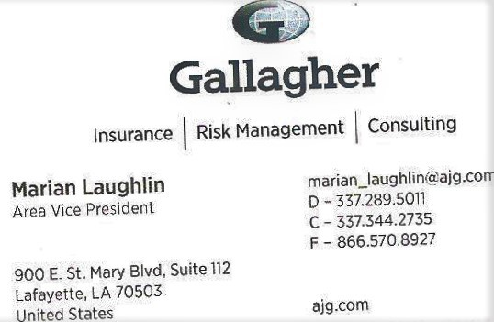
ADS ARE $50.00 PER QUARTER AND THEY APPEAR ON EVERY MONTHLY NEWSLETTER & LFRW.ORG WEBSITE.

WELCOME OUR SPEAKERS FOR AUGUST 15TH: REP BLAKE MIGUEZ CANDIDATE FOR STATE SENATE DIST.22 AND BRANDON TROSCLAIR CANDIDATE FOR SECTRETARY OF STATE!

Do you have the GEAUX VOTE APP FOR YOUR I-PHONE? EASY TO INSTALL: GO TO APPS ON YOUR PHONE, THEN SEARCH FOR “GEAUX VOTE” WITH THE LA. STATE ON APP AND CHOOSE IT AND INSTALL AND THEN OPEN . It is Free. Has
all the elections results, has your Ballot, you can register if you have moved to a new location in the state, city, or parish. Get absentee ballots. It is Great! I like watching election results on the APP as it is so much better than the scroll bar on the TV.

**REMINDER: ARE YOU KEEPING TRACK OF YOUR HOURS? PLEASE TURN IN TO HELEN GRANGER granger_hj@outlook.com (just click on this link to send your email/ hours.)

