

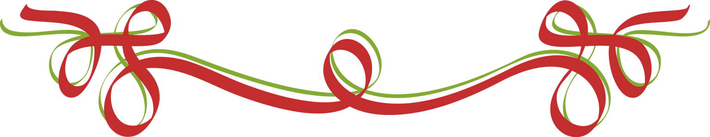



**Our Christmas Meeting**

**It’s All Right to Say:**

**Merry Christmas!**

**Speaker:**  **Kelly Johnson**

**Motivational & Inspirational**

**At:** Savoies The Catering Place

**Time:** 5:30 meet and greet with cash bar

**6:00 dinner**

**Cost:** $20.00 - a pork loin plated dinner

Reservations required by Sunday before the meeting. Cancellations must be made by Monday before noon or payment is required.

**Call Pam for reservations: or e-mail** [**prwc1989@gmail.com**](mailto:prwc1989@gmail.com)



The Naturalization Ceremony

will be on Thursday, December 19th

at 1:00 p.m.

Please bring some baked item to our meeting for the reception that follows the ceremony.

Also, consider coming for the ceremony and reception that follows. This is a very

heart-warming activity.