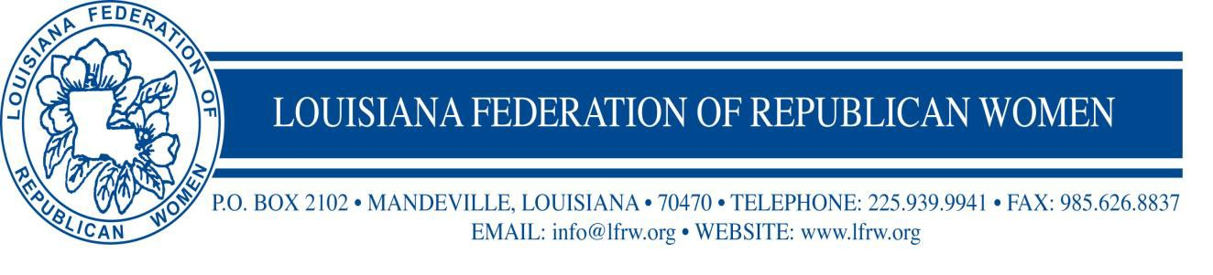

17732 Highland Road Ste G #275 Baton Rouge, Louisiana 70810

OFFICIAL CALL (Issued 9/8/2021
LOUISIANA FEDERATION OF REPUBLICAN WOMEN
2021 LFRW Fall Board of Directors Meeting and Membership Conference

The 2021 Fall Board of Directors Meeting and Membership Conference of the Louisiana Federation of Republican Women will be held in Bossier City, Louisiana, at Hilton Garden Inn Shreveport Bossier City. The Women’s Republican Club of Shreveport will host the Board Meeting and Membership Conference. Gina Martinez, President, and her club have worked very hard to make this meeting as enjoyable and informative as possible.

There will be reports of officers, committee reports, and an update from LA Legislators, along with any other business that may properly come before the Board.

Wanda Aizpurua

LFRW President

Official Call Packet Contents: Official Call
Cover Letter
Registration Form/Hotel Info
Tentative Agenda
Club President Proxy Form (Club Presidents Only)
Standing Rules
Vendor Form
Magnolia Club Form

